Configure Log Shipping:

1. Create users and join them to domain admins:

Administrative Tools > Active Directory Users and Computers

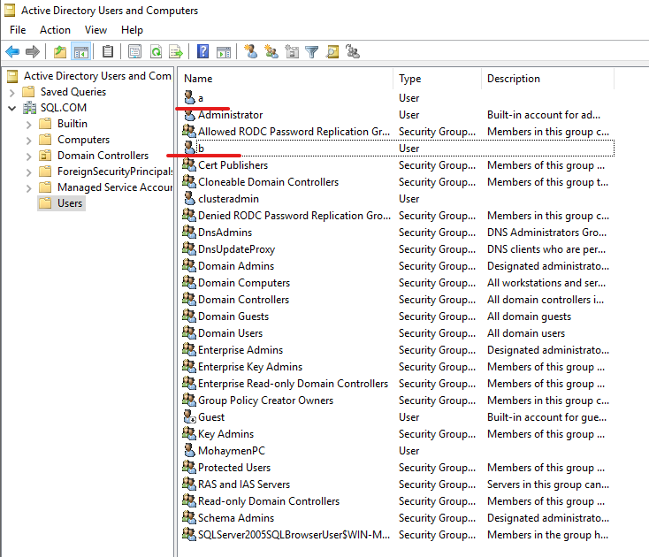

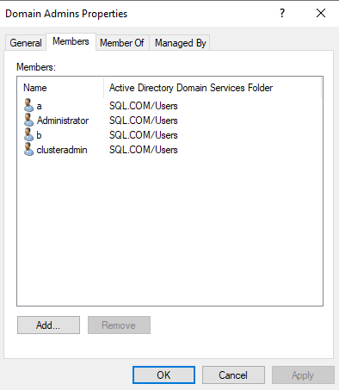

2. Add user a to sql server1 and sql server2 login and give him the sysadmin server role:

Login sql server as sa >

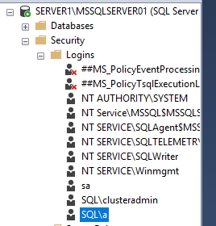

3. Run SQL Server Agent and set Log On As to user SQL\a for SQL Server Agent and SQL Server in server1 and server2:

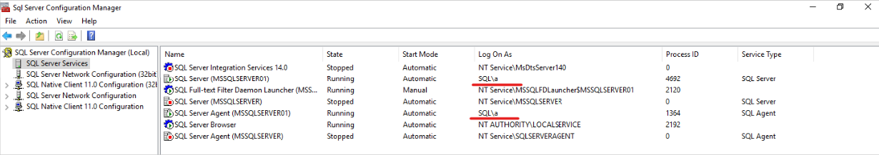

4. Now connect SQL server1 , 2 with Windows Authentication (That connects with SQL\a user)

5. Create a network share folder for the backups in the primary with permission to SQL agent (read) and share it



SQL server agent must have access to this folder

6. Create a network share folder for the copy/restores in the secondary with permission to SQL agent (read and write) and share it

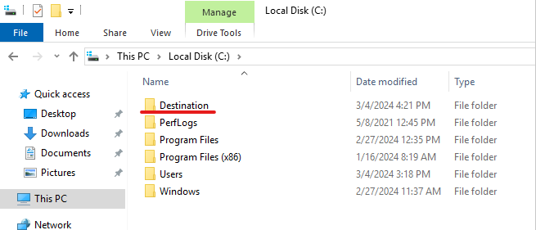

SQL server agent must have access to this folder

7. Take full backup of the primary database to network share

Db_name > Tasks > Ship Transaction Logs

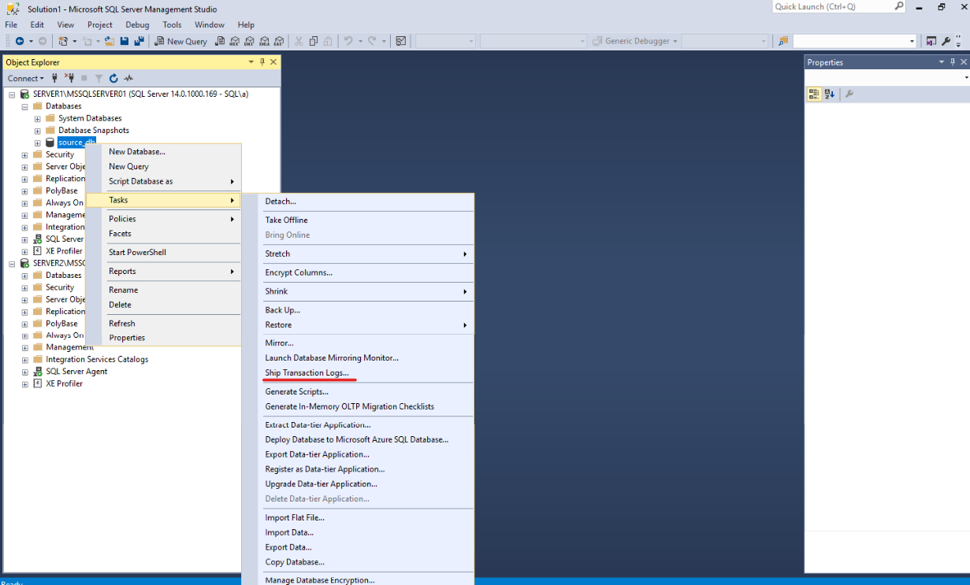

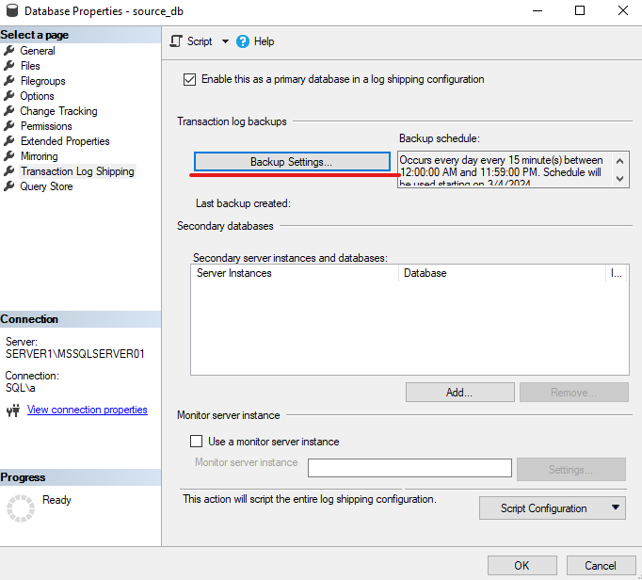

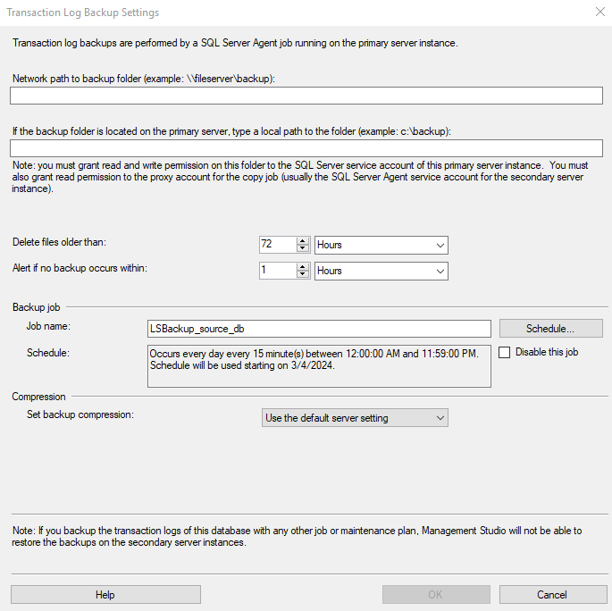

Find network path for source folder:

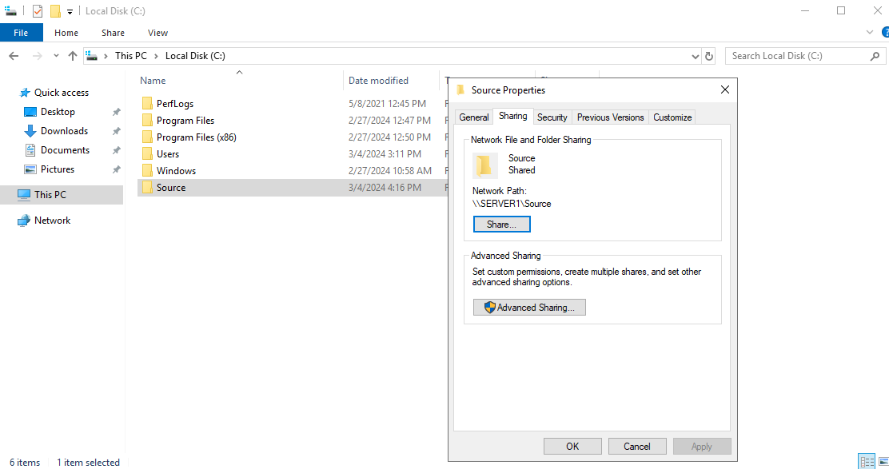

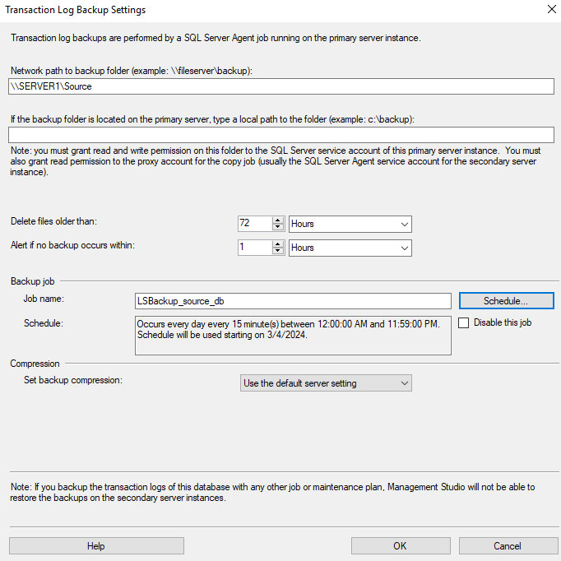

8. Restore full and log backups on secondary server with no recovery option (restoring state)

